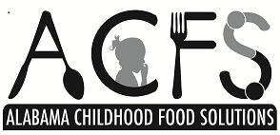

I hereby authorize Alabama Childhood Food Solutions to edit, alter, copy, exhibit, distribute and publish in print, video, audio recorded productions, and on the World Wide Web this material for purposes of publicizing Alabama Childhood Food Solutions programs or other lawful purpose without payment or any other consideration.  
  
If you included minor(s) on this form, by entering your name below, you attest you are the parent/legal guardian of the stated minor(s) and agree that they are also subject to the terms of this document as set forth above.

**NAME OR CHILD’S NAME**

**_________________________________________­­­­_____________________________**

**GUARDIAN NAME (IF CHILD UNDER 18)**

**______________________________________________________________________**

**SIGNATURE AND DATE**

**______________________________________________________________________**